

TRMTracker - Web Services Interface

Version – 1.3

Feb 20th, 2014
Table of Contents
I. Objective 1
1. Overview 1
2. Specifications 1
II. Interface Design 2
1. Process Flow 2
1.1. SOAP Sender 3
1.2. SOAP Receiver 3
1.3. SOAP Parser 3
1.4. Data upload and Position calculations 3
1.5. Logging 3
2. Interface Approach 4
2.1. WSDL Schema Definitions 5
2.2. SOAP Service End Points 6
2.3. SOAP Request Envelope 6
2.4. Request Structure 7
2.5. Response Structure 9
2.6. TRMTracker Data Type 11
3. Technical layer 13
3.1. Exception Handling 13
3.2. Audit log of processed files 14
3.3. Interface security 14
III. Assumptions 15
IV. Acceptance Criteria 16
V. Configuration and Setup 17
VI. Appendices 18

Document History
- Revision History
Date of this revision: 07/11/2026 | Date of next revision (date)

Revision Number | Revision Date | Changed by | Summary of Changes
1.1 | 05/04/2011 | AS | Initial draft prepared for internal circulation.
1.2 | 17/05/2011 | AS | Updated the draft version based on user feedback.
1.3 | 07/12/2012 | KA | Updated based on the changes made as per the additional requirements.
1.4 | 02/20/2014 | AS

Objective
This document is a technical specification for Deal Interface implementation using web services. The followings are covered in this document:
- Interface Design
- Data Load Process
- Errors/Exceptions Handling
- Setup and configuration

Overview
When a deal is entered or updated, Client will automatically send messages. TRMTracker will receive new and amended (including deleted and cancelled) deals in XML format through a SOAP receiver.

Specifications
This section specifies the functional specification of the Interface. TRMTracker provides a SOAP listener where the deals will be published by clients. Simple Object Access Protocol "SOAP” is a lightweight protocol for exchange of information in a decentralized, distributed environment. It is an XML based protocol that consists of three parts: i) an envelope that defines a framework for describing what is in a message and how to process it ii) a set of encoding rules for expressing instances of application-defined data types, and iii) a convention for representing remote procedure calls and responses.

Interface Design

Process Flow
The following diagram demonstrates the overall Process.
- Data transfer from client to TRMTracker is based on standard SOAP protocol. Client will use the SOAP Toolkit and XML gateway to transfer XML data over HTTPS to TRMTracker.
- Client will generate a request to the TRMTracker Web services. This request will use the predefined WSDL schema. WSDL schema for the deals is defined below later.
- TRMTracker will process the deals and send response to the clients in XML format.

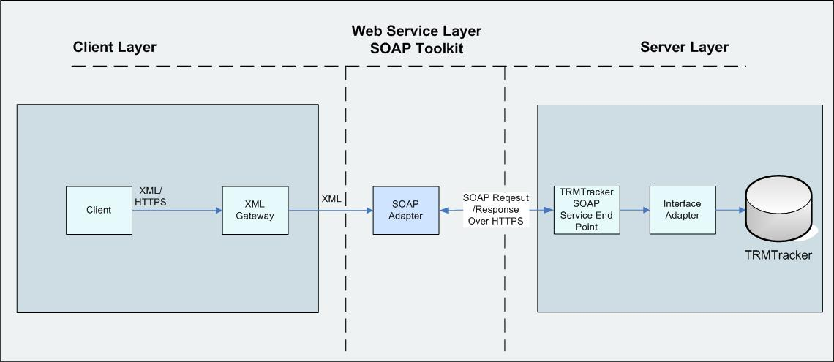

The following are the main Processes for the web services interface
- SOAP sender
- SOAP Receiver
- SOAP parser
- Data Upload and Position calculations
- Logging

1.1. SOAP Sender
- SOAP web services communicate with applications using XML messages.
- The request is sent following the WSDL schema defined later in the document.

1.2. SOAP Receiver
- TRMTracker web service receives the request and sends response back to the client.

1.3. SOAP Parser
- The SOAP Parser reads and writes SOAP XML documents. The Parser converts SOAP XML documents to or from entry objects in a simple, straightforward fashion. When writing the XML document, the Parser uses attributes from the entry to build the document.

1.4. Data upload and Position calculations
- The interface adaptor will load the XML data to the staging table.
- TRMTracker will create deals in the system and run the calculations

1.5. Logging
- TRMTracker will log all the relevant information related to the import. All the data/values, inserted/updated and deleted, of the deal will be displayed in a Transaction Audit Log Report.
- Import Status will be published in the message board to the user.

Interface Approach
The interface approach is shown in the diagram below

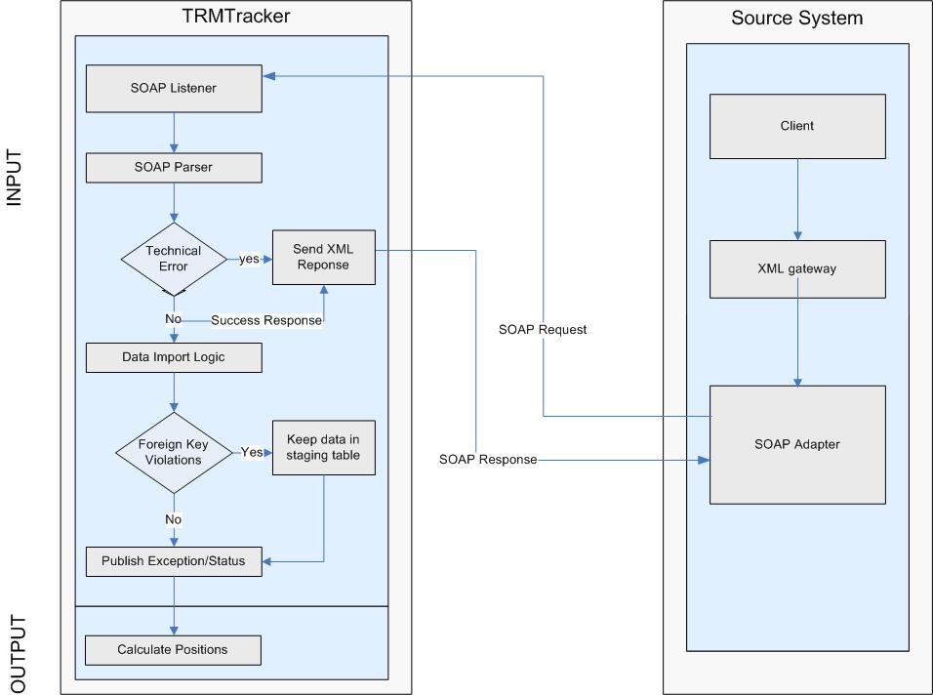
- TRMTracker web services listens for SOAP request from the client.
- Client will send the data to the TRMTracker web interface following the WSDL schema.
- All the data will be received in the Key-Value pair, where “Key” is the field name and “Value” is the value associated with the key.
- TRMTracker will process the XML data and send response back to the client.
- While creating deals, several static data are required (i.e., Trader, Counterparty etc). If any missing static data is found, then exceptions will be generated. Depending on the data mapping approach utilized a user/administrator will have to manually enter the missing static data in TRMTracker and reprocess deals from the staging tables or add data in the source and send the request Required static data (fields) are mentioned below under section 3.3. Reprocessing of the deal from the staging table will be possible after static data corrections. Triggering this reprocessing will be possible from the TRMTracker user interface for users with applicable rights/roles.

WSDL Schema Definitions
Web services schema are required for Sending and processing SOAP request. It is a standard specification for describing networked, XML – based services. It provides a simple way for service providers to describe the basic format of request to their system regardless of the underlying runtime implementation. It contains the following part.
1. Web service Interface Definition – describes the generic Web Service, including the port type, message, parts of the message and bindings.
2. Web service implementation – definition of the services and ports.
The operational editor allows you to create and modify port types, message and types. These artifacts are part of the web service interface document.

SOAP Service End Points
Following is the SOAP Service Endpoints.

Environment | URL
Development | http://localhost/Trmtracker_pnm/trmclient/trmsoaplistener.php?wsdl
UAT
Production

SOAP Request Envelope
The Following diagram illustrates the SOAP request envelope.

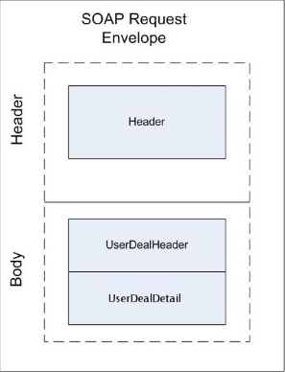 |  | 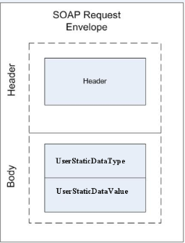

Request Structure
The Following is the SOAP request structure.
<soapenv:Envelope xmlns:soapenv="http://schemas.xmlsoap.org/soap/envelope/" xmlns:psap="http://www.farrms.us/PSAPIInterface/">
<soapenv:Header/>
<soapenv:Body>
<psap:PSStaticDataService>
<!--Optional:-->
<Header>
<!--Optional:-->
<RequesterInfo>
<!--Optional:-->
<ID>?</ID>
<!--Optional:-->
<Name>?</Name>
<!--Optional:-->
<Version>?</Version>
<!--Optional:-->
<System>?</System>
<!--Optional:-->
<Effective_DateTime>?</Effective_DateTime>
</RequesterInfo>
</Header>
<Request>
<StaticDataType StaticDataType="?">
<!--1 to 1000 repetitions:-->
<StaticData>
<!--1 to 1000 repetitions:-->
<Value>
<Key>?</Key>
<Value>?</Value>
</Value>
</StaticData>
</StaticDataType>
</Request>
<!--Optional:-->
<Response>
<StaticDataResult StaticDataID="?">
<ResultCode>?</ResultCode>
<ResultMessage>?</ResultMessage>
</StaticDataResult>
<!--1 to 1000 repetitions:-->
<Messages>
<!--1 or more repetitions:-->
<Message>?</Message>
</Messages>
</Response>
</psap:PSStaticDataService>
</soapenv:Body>
</soapenv:Envelope>

Response Structure
The Following is the SOAP request structure.
<SOAP-ENV:Envelope xmlns:SOAP-ENV="http://schemas.xmlsoap.org/soap/envelope/" xmlns:xsd="http://www.w3.org/2001/XMLSchema" xmlns:xsi="http://www.w3.org/2001/XMLSchema-instance" xmlns:SOAP-ENC="http://schemas.xmlsoap.org/soap/encoding/">
<SOAP-ENV:Body>
<PSStaticDataService xmlns="http://www.farrms.us/PSAPIInterface/">
<Request xmlns="">
<StaticDataType StaticDataType="?">
<StaticData>
<Value>
<Key>?</Key>
<Value>?</Value>
</Value>
</StaticData>
</StaticDataType>
</Request>
<Response xmlns="">
<StaticDataResult>
<ResultCode>Success</ResultCode>
<ResultMessage></ResultMessage>
</StaticDataResult>
<Messages>
<Message></Message>
</Messages>
</Response>
</PSStaticDataService>
</SOAP-ENV:Body>
</SOAP-ENV:Envelope>

The response provides the status of each deal submitted to TRMTracker. <Resultcode> element indicates whether the data were successfully submitted or not. If there are errors, <ResultMessage> element provides the detail error message.
Following are the possible values of Result code

Code | Description
E | Error
S | Success

The detail error message indicates the cause of the errors. Error can be due to some technical reasons, in which case the data is not processed at all or due to missing data. The detail message provides the detail information regarding the missing data and this message is also published in the message board. Users will have to insert the missing data and reprocess the data from the User Interface in TRMTracker.

API

DealImport API Operation
DealImport Operation will import the Deal in TRMTracker.

Following table shows the DealImport elements
Elements | Descriptions
<deal> | This element contains the Deal ID as the attribute
DealHeader | This element contains the deal header information in Key Value format.
DealDetail | This element contains the deal detail information in Key Value format.

DealHeader can have one to multiple deals and DealDetail one to multiple detail items for that Deal

Input
Input Parameter name | Parameter Type Value | Parameter Description
Source_deal_id | String | Source Deal Id as Deal attribute
Key | String | Column name as Key
Value | String | Value of particular column as Value

The following table shows the DealImport data types. All the required fields mentioned below in the table should be provided. If all the fields are not provided it gives an Error message

Field name | Field Description | Header or Detail Field | Type | Length | Required | Comment
source_deal_id | Source Deal Id | H | String | 50 | Y | Deal Id in the feeder system that is unique.
term_start | Term Start | D | Datetime | 8 | Y | Contract month begin
term_end | Term End | D | Datetime | 8 | Y | Contract month end
leg | Leg | D | Integer | 4 | Y | Leg of the contract month to represent buy and sell side.
expiration_date | Expiration Date | D | Datetime | 8 | Y | Contract expiration date.
fixed_float_leg | Fixed Float Leg | D | String | 1 | Y | 'f' for fixed leg and 't' for floating leg.
buy_sell_flag | Buy Sell Flag | D | String | 1 | Y | 'b' for buy and 's' for sell.
source_curve_id | Source Curve Id | D | String | 50 | N | Required when Fixed Float Leg is’t’ (i.e., floating). FK to Curve Id in Price Curve Definition data.
price | Price | D | Float | 8 | N | Fixed price component of the deal for the leg.
price_currency | Price Currency Id | D | String | 50 | N | Currency the price is in. FK to Currency Id in Currency data.
option_strike_price | Option Strike Price | D | Float | 8 | N | Used for options to represent strike price.
deal_volume | Deal Volume | D | Float | 8 | Y | Volume for the leg.
volume_frequency | Volume Frequency | D | String | 1 | Y | 'm' for monthly and 'd' for daily
volume_uom | Volume UOM Id | D | String | 50 | Y | Volume units of measure. FK to UOM Id in Units of Measure data.
block_description | Block Description | H | String | 100 | N | Block Description field for the leg
description | Description | H | String | 100 | N | Description field for the leg
formula_id | Formula Id | D | Integer | 4 | N | ID for formula pricing to be defined in TRMTracker
deal_date | Deal Date | H | Datetime | 8 | Y | Deal date.
external _deal _id | External Deal Id | H | String | 50 | N | Used for cross-reference if needed.
physical_financial_flag | Physical Financial Flag | D | String | 10 | Y | 'p' for physical and 'f' for financial
structured_deal_id | Structured Deal Id | H | String | 50 | N | If this deal belongs to a structured deal group then this would be FK to that structured deal id
counterparty | Source Counterparty Id | H | String | 50 | Y | Counterparty for the deal. FK with the Counterparty Id in Counterparty data.
deal_type | Source Deal Type Id | H | String | 50 | Y | Deal type which is FK with the Deal Type Id in Deal Type data.
deal_sub_type | Source Deal Sub Type Id | H | String | 50 | N | Deal sub type which is FK with the Deal Sub Type Id in Deal Type data.
option_flag | Option Flag | H | String | 1 | Y | 'y' means Yes and 'n' otherwise to indicate whether the deal is option or not.
option_type | Option Type | H | String | 1 | N | For option deal 'c' means Call and 'p' means Put Option.
option_excercise_type | Option Exercise Type | H | String | 1 | N | For option deal 'a' means American, 'e' means European.
book_id1 | Source Book Id1 | H | String | 50 | Y | First book group field for the deal (FK with Book Id in Book data).
book_id2 | Source Book Id2 | H | String | 50 | N | Second book group filed for the deal (FK with Book Id in Book data). Empty means not used.
book_id3 | Source Book Id3 | H | String | 50 | N | Third book group filed for the deal (FK with Book Id in Book data). Empty means not used.
book_id4 | Source Book Id4 | H | String | 50 | N | Fourth book group filed for the deal (FK with Book Id in Book data). Empty means not used.
description1 | Description1 | H | String | 100 | N | Description field 1.
description2 | Description2 | H | String | 50 | N | Description field 2.
description3 | Description3 | H | String | 50 | N | Description field 3.
deal_category | Deal Category Id | H | Integer | 4 | Y | 475 for Real, 476 for Forecasted, 477 for Hypothetical.
trader | Source Trader Id | H | String | 50 | Y | Trader of the deal. FK with Trader Id in Trader data.
hdr_buysell_flag | Header Buy Sell Flag | H | String | 1 | Y | ‘b’ for Buy and ‘s’ for Sell
broker | Source Broker ID | H | String | 50 | N | Null or “no broker”
contract | Contract ID | H | String | 50 | N | Unique contract id from source system

Sample Request
<deal source_deal_id="1572305">
<DealHeader>
<!--1 to 1000 repetitions:-->
<value>
<Key>BLOCK_DESCRIPTION</Key>
<value></value>
</value>
<value>
<Key>DESCRIPTION</Key>
<value></value>
</value>
<value>
<Key>DEAL_DATE</Key>
<value>2013-01-01</value>
</value>
<value>
<Key>EXT_DEAL_ID</Key>
<value></value>
</value>
<value>
<Key>PHYSICAL_FINANCIAL_FLAG</Key>
<value>p</value>
</value>
<value>
<Key>STRUCTURED_DEAL_ID</Key>
<value></value>
</value>
<value>
<Key>COUNTERPARTY</Key>
<value>Transwestern</value>
</value>
<value>
<Key>SOURCEDEALTYPEID</Key>
<value>Physical</value>
</value>
<value>
<Key>SOURCEDEALSUBTYPEID</Key>
<value></value>
</value>
<value>
<Key>OPTIONFLAG</Key>
<value>n</value>
</value>
<value>
<Key>OPTIONTYPE</Key>
<value></value>
</value>
<value>
<Key>OPTIONEXTYPE</Key>
<value></value>
</value>
<value>
<Key>BOOK_ID1</Key>
<value>Baseload</value>
</value>
<value>
<Key>BOOK_ID2</Key>
<value></value>
</value>
<value>
<Key>BOOK_ID3</Key>
<value></value>
</value>
<value>
<Key>BOOK_ID4</Key>
<value></value>
</value>
<value>
<Key>DESCRIPTION1</Key>
<value></value>
</value>
<value>
<Key>DESCRIPTION2</Key>
<value></value>
</value>
<value>
<Key>DESCRIPTION3</Key>
<value></value>
</value>
<value>
<Key>DEALCATEGORYID</Key>
<value>Real</value>
</value>
<value>
<Key>TRADER</Key>
<value>TWIP</value>
</value>
<value>
<Key>HDR_BUYSELL_FLAG</Key>
<value>b</value>
</value>
<value>
<Key>BROKER</Key>
<value></value>
</value>
<value>
<Key>CONTRACT</Key>
<value></value>
</value>
<value>
<Key>Template</Key>
<value>Physical NG</value>
</value>
</DealHeader>
<!--1 to 1000 repetitions:-->
<DealDetail>
<!--1 to 1000 repetitions:-->
<value>
<Key>TERM_START</Key>
<value>2013-01-01</value>
</value>
<value>
<Key>TERM_END</Key>
<value>2013-01-31</value>
</value>
<value>
<Key>LEG</Key>
<value>1</value>
</value>
<value>
<Key>EXPIRATION_DATE</Key>
<value>2013-01-31</value>
</value>
<value>
<Key>FIXED_FLOAT_LEG</Key>
<value>f</value>
</value>
<value>
<Key>BUY_SELL_FLAG</Key>
<value>b</value>
</value>
<value>
<Key>TRADE_PRICE</Key>
<value>5</value>
</value>
<value>
<Key>PRICE_CURRENCY</Key>
<value>USD</value>
</value>
<value>
<Key>OPTION_STRIKE_PRICE</Key>
<value></value>
</value>
<value>
<Key>DEAL_VOLUME</Key>
<value>500</value>
</value>
<value>
<Key>VOLUME_FREQUENCY</Key>
<value>m</value>
</value>
<value>
<Key>VOLUME_UOM</Key>
<value>Mwh</value>
</value>
</DealDetail>
</deal>

Sample Response
<Response xmlns="">
<DealResult>
<ResultCode>Error</ResultCode>
<ResultMessage>Request contains invalid columns.</ResultMessage>
</DealResult>
<Messages>
<Message>Process table contains invalid columns. Columns :- FORMULA_ID2 are not present in rule.</Message>
</Messages>
</Response>

ShapedDealVolumeImport API Operation
ShapedDealVolumeImport Operation will import the Hourly Shaped Volume and Price in TRMTracker.

Following table shows the ShapedDealVolumeImport elements
Elements | Descriptions
ShapedDealVolume | This element contains the deal hourly value in Key Value format.

Input
Input Parameter name | Parameter Type Value | Parameter Description
Key | String | Column name as Key
Value | String | Value of particular column as Value

The following table shows the ShapedDealVolume data types. All the required fields mentioned below in the table should be provided. If all the fields are not provided, it gives an Error message

Field name | Field Description | Type | Length | Required | Comment
deal_id | Source Deal Id | String | 50 | Y | Deal Id in the feeder system that is unique.
term_date | Day | Datetime | 8 | Y | Date
leg | Leg | Integer | 4 | Y | Leg of the deal which shaped volume belongs
Hour | Hour | Integer | 1 | Y | Hour
volume | Hourly Volume | Float | 8 | Y | Volume
price | Hourly Price | Float | 8 | Y | Price
Is_dst | DST indicator | Integer | 4 | N | Indicates whether particular column is DST or not. Possible values are 01 or 1

Sample Request
<ShapedDealVolume>
<!--1 to 1000 repetitions:-->
<Value>
<Key>deal_id</Key>
<Value>503544_P</Value>
</Value>
<Value>
<Key>term_date</Key>
<Value>2014-01-01</Value>
</Value>
<Value>
<Key>hr</Key>
<Value>1</Value>
</Value>
<Value>
<Key>leg</Key>
<Value>1</Value>
</Value>
<Value>
<Key>volume</Key>
<Value>100</Value>
</Value>
<Value>
<Key>price</Key>
<Value>5</Value>
</Value>
<Value>
<Key>is_dst</Key>
<Value>0</Value>
</Value>
</ShapedDealVolume>

Sample Response
<Response xmlns="">
<VolatilityResult>
<ResultCode>Success</ResultCode>
<ResultMessage>Import process has been run and will complete shortly.</ResultMessage>
</DealResult>
<Messages>
<Message> Import process has been run and will complete shortly. Please Check/Refresh your message board.</Message>
</Messages>
</Response>

PriceCurveImport API Operation
PriceCurveImport Operation will import the Hourly Shaped Volume and Price in TRMTracker.

Following table shows the PriceCurveImport elements
Elements | Descriptions
PriceCurve | This element contains the price curve information in Key Value format.

Input
Input Parameter name | Parameter Type Value | Parameter Description
Key | String | Column name as Key
Value | String | Value of particular column as Value

The following table shows the PriceCurve data types. All the required fields mentioned below in the table should be provided. If all the fields are not provided, it gives an Error message

Field name | Field Description | Type | Length | Required | Comment
source_curve_def_id | Source Curve ID | String | 50 | Y | Unique Price Curve ID of the corresponding price curve (i.e. ICE-PV)
as_of_date | AS of date | Datetime | 8 | Y | Price Publish date
assessment_curve_type_value_id | Assessment type | Integer | 4 | Y | System required value always use 77
curve_source_value_id | Curve Source | Integer | 4 | Y | System required curve source value id always use 4500
maturity_date | Maturity date | Datetime | 8 | Y | Maturity date (delivery date of the price)
bid_value | Bid Price | Float | 8 | Y | Bid Price
ask_value | Ask Price | Float | 8 | Y | Ask Price
curve_value | Mid Price | Float | 8 | Y | Mid Price
is_dst | DSTflag | Integer | 4 | Y | Indicates, if particular hour is DST or not. Possible values are 0 or 1.

Sample Request
<PriceCurve>
<!--1 to 1000 repetitions:-->
<Value>
<Key>source_curve_def_id</Key>
<Value>ICE-PV</Value>
</Value>
<Value>
<Key>as_of_date</Key>
<Value>7/17/2013</Value>
</Value>
<Value>
<Key>assessment_curve_type_value_id</Key>
<Value>77</Value>
</Value>
<Value>
<Key>curve_source_value_id</Key>
<Value>4500</Value>
</Value>
<Value>
<Key>maturity_date</Key>
<Value>8/1/2013</Value>
</Value>
<Value>
<Key>bid_value</Key>
<Value>39.23</Value>
</Value>
<Value>
<Key>ask_value</Key>
<Value>39.23</Value>
</Value>
<Value>
<Key>curve_value</Key>
<Value>39.23</Value>
</Value>
<Value>
<Key>is_dst</Key>
<Value>0</Value>
</Value>
</PriceCurve>

Sample Response
<Response xmlns="">
<VolatilityResult>
<ResultCode>Success</ResultCode>
<ResultMessage>Import process has been run and will complete shortly.</ResultMessage>
</DealResult>
<Messages>
<Message> Import process has been run and will complete shortly. Please Check/Refresh your message board.</Message>
</Messages>
</Response>

VolatilityImport API Operation
VolatilityImport Operation will import the Hourly Shaped Volume and Price in TRMTracker.

Following table shows the VolatilityImport elements
Elements | Descriptions
Volatility | This element contains the volatility information in Key Value format.

Input
Input Parameter name | Parameter Type Value | Parameter Description
Key | String | Column name as Key
Value | String | Value of particular column as Value

The following table shows the Volatility data types. All the required fields mentioned below in the table should be provided. If all the fields are not provided, it gives an Error message

Field name | Field Description | Type | Length | Required | Comment
as_of_date | As of Date | Datetime | 8 | Y | Publication Date
curve_id | Curve Id | String | 50 | Y | Unique Price Curve ID of the corresponding price curve (i.e. ICE-PV)
curve_source_value_id | Curve source Id | String | 50 | Y | Fixed value (i.e. Curve Master Source)
term | Date | Datetime | 8 | Y | Maturity date (delivery date)
value | Curve value | Float | 8 | Y | Volatility value
granularity | Granularity | Integer | 4 | N | Granularity value(Daily, Monthly, Yearly, Hourly, Quarterly)
strike_price | Strike Price | float | 8 | N | Option Deal price.
vol_cor_header_id | Correlation Header id | Integer | 4 | N | Correlation Header id.

Sample Request
<Volatility>
<!--1 to 1000 repetitions:-->
<Value>
<Key>as_of_date</Key>
<Value>1/9/2009</Value>
</Value>
<Value>
<Key>curve_id</Key>
<Value>testCurve</Value>
</Value>
<Value>
<Key>curve_source_value_id</Key>
<Value>Curve Master Source</Value>
</Value>
<Value>
<Key>term</Key>
<Value>1/9/2015</Value>
</Value>
<Value>
<Key>value</Key>
<Value>0.99</Value>
</Value>
<Value>
<Key>granularity</Key>
<Value>Daily</Value>
</Value>
<Value>
<Key>strike_price</Key>
<Value>0.99</Value>
</Value>
</Volatility>

Note: Granularity and Strike price are optional.

Sample Response
<Response xmlns="">
<VolatilityResult>
<ResultCode>Success</ResultCode>
<ResultMessage>Import process has been run and will complete shortly.</ResultMessage>
</DealResult>
<Messages>
<Message> Import process has been run and will complete shortly. Please Check/Refresh your message board.</Message>
</Messages>
</Response>

3.5. CorrelationImport API Operation
CorrelationImport Operation will import the Hourly Shaped Volume and Price in TRMTracker.

Following table shows the CorrelationImport elements
Elements | Descriptions
Correlation | This element contains the Correlation Information in Key Value format.

Input
Input Parameter name | Parameter Type Value | Parameter Description
Key | String | Column name as Key
Value | String | Value of particular column as Value

The following table shows the Correlation data types. All the required fields mentioned below in the table should be provided. If all the fields are not provided, it gives an Error message

Field name | Field Description | Type | Length | Required | Comment
as_of_date | As of Date | Datetime | 8 | Y | Publication Date
curve_id_from | Curve Id from | String | 50 | Y | Unique Price Curve ID of the corresponding price curve (i.e. ICE-PV)
curve_id_to | Curve Id to | String | 50 | Y | Unique Price Curve ID of the corresponding price curve (i.e. ICE-PV)
term1 | Date 1 | Datetime | 8 | Y | Maturity date (delivery date)
term2 | Date 2 | Datetime | 8 | Y | Maturity date (delivery date)
curve_source_value_id | Curve source | String | 50 | Y | Fixed value (i.e. Curve Master Source)
value | Curve value | Float | 8 | Y | Correlation value
vol_cor_header_id | Correlation header id | Integer | 4 | N

Sample Request
<Correlation>
<!--1 to 1000 repetitions:-->
<Value>
<Key>as_of_date</Key>
<Value>1/9/2009</Value>
</Value>
<Value>
<Key>curve_id_from</Key>
<Value>testCurve1</Value>
</Value>
<Value>
<Key>curve_id_to</Key>
<Value>testCurve2</Value>
</Value>
<Value>
<Key>term1</Key>
<Value>1/9/2015</Value>
</Value>
<Value>
<Key>term2</Key>
<Value>1/9/2015</Value>
</Value>
<Value>
<Key>curve_source_value_id</Key>
<Value>Curve Master Source</Value>
</Value>
<Value>
<Key>value</Key>
<Value>0.99</Value>
</Value>
<Value>
<Key>vol_cor_header_id</Key>
<Value>NULL</Value>
</Value>
</Correlation>

Note: ‘vol_cor_header_id’ is optional.

Sample Response
<Response xmlns="">
<VolatilityResult>
<ResultCode>Success</ResultCode>
<ResultMessage>Import process has been run and will complete shortly.</ResultMessage>
</DealResult>
<Messages>
<Message> Import process has been run and will complete shortly. Please Check/Refresh your message board.</Message>
</Messages>
</Response>

3.6. StaticDataImport API Operation
StaticDataImport Operation will import static data value in TRMTracker.

Following table shows the StaticDataImport elements
Elements | Descriptions
<StaticDataType> | This element contains the Static Data Type as the attribute.
StaticData | This element contains the static data value information in Key Value format.

Input
Input Parameter name | Parameter Type Value | Parameter Description
Key | String | Column name as Key
Value | String | Value of particular column as Value

The following table shows the Correlation data types. All the required fields mentioned below in the table should be provided. If all the fields are not provided, it gives an Error message

Field name | Field Description | Type | Length | Required | Comment
type_id | Static Data Type | Integer | 4 | Y | Static data type id
code | Static Data Value Code | String | 500 | Y | Code
description | Static Data Value Description | String | 500 | Y | Description
Entity_id | Entity Id | Integer | 4 | N | Entity Id
xref_value_id | Xref Value id | String | 50 | N | Xref Value Id
xref_value | Xref value | String | 250 | N | Xref Value
Category_id | Category Id | Int | 4 | N | Category Id

Sample Request
<StaticDataType StaticDataType="StaticDataTypeName">
<Correlation>
<!--1 to 1000 repetitions:-->
<Value>
<Key>code</Key>
<Value>testsdvcode</Value>
</Value>
<Value>
<Key>description</Key>
<Value>testsdvdescription</Value>
</Value>
</Correlation>

Sample Response
<Response xmlns="">
<VolatilityResult>
<ResultCode>Success</ResultCode>
<ResultMessage>Import process has been run and will complete shortly.</ResultMessage>
</DealResult>
<Messages>
<Message> Import process has been run and will complete shortly. Please Check/Refresh your message board.</Message>
</Messages>
</Response>

Technical layer
Interface adaptor will fully be developed using SOAP and web services. When the listener receives the request, it will process the request and parse XML using SOAP parser. All the Errors are logged in the application. Notifications of the error will be sent via email and message board of the application to the users who has privileges to the “Job Notification Group” type roles in the application.

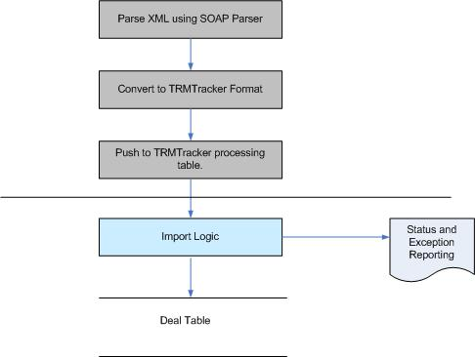

Exception Handling
Errors are generated in the application in several ways in TRMTracker. The detail status of each import process is published in the message board. Based on the configuration, email is also sent to users if error occurs.

There are following types of exceptions:

- Foreign key violations: This type of exception will be raised when required data (i.e., , Curve def, Currency, UOM, etc) e is missing in the data imported.. The response XML will return error status for these kinds of Errors.
For an example,
Sample Request
<StaticDataType StaticDataType="TestDemo">
<Correlation>
<!--1 to 1000 repetitions:-->
<Value>
<Key>code</Key>
<Value>testsdvcode</Value>
</Value>
<Value>
<Key>description</Key>
<Value>testsdvdescription</Value>
</Value>
</Correlation>
When the request with Static Data Type using the ‘TestDemo’ is passed, the response will be

Sample Response
<Response xmlns="">
<StaticDataResult>
<ResultCode>Error</ResultCode>
<ResultMessage> Data error for Type : TestDemo is not present in system.</ResultMessage>
</DealResult>
<Messages>
<Message Data error for Type: TestDemo is not present in system.. Please check your data.</Message>
</Messages>
</Response>
Here the Static Data Type with name ‘TestDemo’ is not present in the system.

- Technical Error: This type of exception will be raised when the web service receives invalid XML files or the required Key Fields are missing from the XML request. The response XML will return Error status and sends messages to the concerned users.
For an Example
Sample Request for correlation import
<Correlation>
<!--1 to 1000 repetitions:-->
<Value>
<Key>as_of_date</Key>
<Value>1/9/2009</Value>
</Value>
<Value>
<Key>curve_id_to</Key>
<Value>testCurve2</Value>
</Value>
<Value>
<Key>term1</Key>
<Value>1/9/2015</Value>
</Value>
<Value>
<Key>term2</Key>
<Value>1/9/2015</Value>
</Value>
<Value>
<Key>curve_source_value_id</Key>
<Value>Curve Master Source</Value>
</Value>
<Value>
<Key>value</Key>
<Value>0.99</Value>
</Value>
<Value>
<Key>vol_cor_header_id</Key>
<Value>NULL</Value>
</Value>
</Correlation>

Sample Response
<Response xmlns="">
<CorrelationlResult>
<ResultCode>Error</ResultCode>
<ResultMessage>Data error for CurveId From: Curve Id From Is NULL.</ResultMessage>
</DealResult>
<Messages>
<Message> Data error for CurveId From: Curve Id From Is NULL.. Please check your data.</Message>
</Messages>
</Response>
Here the ‘curveID from’ is not an optional. Hence it is needed.

Audit log of processed files
TRMTracker will maintain log of all files that have been imported. Users can run report of the logs and detailed status via ‘Transaction Audit Log Report’.

Interface security
For securing the Interface, the access to soap listener for unauthorized parties is disabled .The following resolution will be implemented.
- Only accept connection from trusted source.
To accept the connection from trusted source, TRMTracker takes the information only of the source machine.

Appendices

